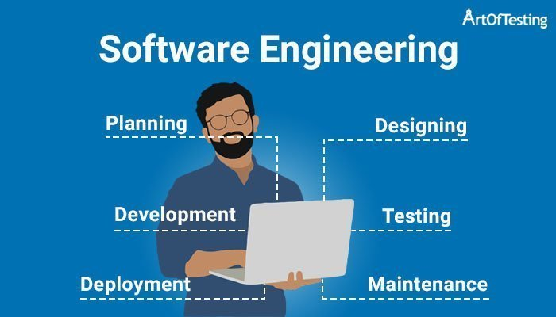  Software Quality, Security and Production Readiness: Research for CivicConnect  Assignment 3 | Abstract  This report investigates software quality, security and production readiness for CivicConnect. It covers risk-based verification, security practices and operational concerns, highlighting approaches and evidence that can support engineering decisions in Milestone 3.  603090: Ofentse Vilakazi 602330: Liam Axel Ince 601950: Tetelo Phahladira  SEN381

Table of Contents
Question 1 3
Question 2: 8
Question 4: 15
AI Research & Verification Record 17
References 18

Question 1
1.1 Quality Strategy Foundations
A software quality strategy is a planned approach used to make sure that quality is considered throughout software development, rather than only checking the software once it has been completed. Research supports carrying out quality activities throughout development instead of relying only on testing at the end (Naprawski, 2023).
Quality Assurance (QA) focuses mainly on how software is developed. Its purpose is to prevent defects by making sure that suitable development practices, standards and procedures are followed. This means that QA takes place throughout the software development lifecycle and is not only concerned with the final product (Depar, et al., 2021).
Quality Control (QC) focuses on checking the software and other work produced during development to find defects and determine whether the expected quality requirements have been met. The main difference is that QA tries to prevent problems through good development processes, while QC focuses on finding problems in the work that has been produced (Ishikawa & Kato, 2024).
Verification checks whether the software meets its specified requirements. In simple terms, it asks whether the software has been built correctly. Verification is not limited to testing and can involve different methods of checking whether the software works as required. Different verification methods can also check different aspects of software correctness (Lathouwers, et al., 2025).
Validation checks whether the software actually meets its intended purpose and the needs of its users. In simple terms, it asks whether the team is building the right product. A system could meet all its written requirements but still not properly solve the problem it was created for. Verification and validation are therefore both important because they check software quality from different perspectives (Cederbladh, et al., 2024).
Together, QA, QC, verification and validation support software quality by helping to prevent defects, identify problems, check that requirements have been met and confirm that the software meets its intended purpose.
1.2 Risk-Based Testing and Verification
Risk-based testing is an approach where testing and verification activities are prioritised according to the level of risk in different parts of a software system. Instead of testing every part of the system with the same level of effort, more attention is given to areas where failure is more likely or could have more serious consequences. This helps teams use their available testing time and resources where they are most needed (Ardila, et al., 2021).
The level of risk can be assessed by considering likelihood and impact. Likelihood refers to how likely a failure is to occur, while impact considers how serious the consequences would be if it occurred. A failure that is both likely and has serious consequences would therefore require more verification than one that is unlikely and has little impact (Ardila, et al., 2021).
The business and technical criticality of a feature can also affect the level of verification needed. Some features are more important to users, business processes or the operation of the system, while technically critical areas may affect important system functions. Higher-risk and more critical areas may therefore require deeper verification, such as additional test cases or different testing techniques. Lower-risk areas should still be tested but may require less testing effort. Risk-based testing therefore helps teams decide where their verification resources should be focused (Ardila, et al., 2021).

1.3 Comparison of Verification Evidence
Different types of testing provide evidence about different aspects of software quality. Unit, integration/API and system/end-to-end testing are complementary because they examine the software at different levels. Using them together can therefore identify problems that may not be detected by relying on only one form of testing.

Verification evidence | What it checks | Strong at exposing | Cannot prove on its own
Unit testing | Individual functions, methods or components | Problems in the logic and behaviour of individual components (De Lucia, et al., 2024). | That components work correctly when connected to other parts of the system
Integration/API testing | Interactions between connected components, APIs or services | Communication, dependency and interaction problems that appear when components are combined (Bogner, et al., 2022). | That the complete system and user workflows work correctly
System/E2E testing | The behaviour of the complete integrated system and its workflows | Problems that appear when several parts of the system are used together (Agh, et al., 2024). | That every internal condition, code path or individual component has been tested

These forms of verification are therefore complementary rather than interchangeable. Unit testing provides evidence about individual components, integration testing checks how components interact, and system/end-to-end testing checks the behaviour of the complete system. No single testing level can provide complete evidence of software quality.
1.4 Automation and Quality Gates
Test automation allows software tests and other quality checks to be carried out automatically instead of requiring a person to perform them every time the software changes. In Continuous Integration (CI), automated tests can be run whenever changes are added to the software, allowing problems to be identified earlier and providing developers with faster feedback. Research has found that more mature test automation practices in CI are associated with improved software quality and shorter release cycles (Liu, et al., 2022).
Automation also makes verification more repeatable and consistent because the same checks can be performed whenever changes are made. This reduces the need to manually repeat the same tests and allows teams to regularly check whether new changes have introduced problems. However, the benefits of automation depend on the quality and coverage of the automated tests themselves. Research into software quality practices shows that simply using CI does not mean that all relevant quality activities are being performed (Khatami & Zaidman, 2024) .

Quality gates can be used within this process to decide whether software is allowed to move to the next stage of development. A quality gate may check whether certain conditions have been met, such as automated tests passing or other required quality checks succeeding. If these conditions are not met, the change can be stopped until the problem has been addressed. Quality gates therefore help teams apply agreed quality checks consistently before allowing software to progress.
However, a green pipeline does not prove that the software is completely correct or ready for release. A successful pipeline only shows that the checks included in the pipeline have passed. Important tests may be missing, requirements may have been misunderstood, or some quality risks may not be covered by automated tests. Automated testing of areas such as performance, reliability, security and scalability can also be challenging (Alégroth, et al., 2023). Therefore, “all automated tests passed” is not enough evidence on its own to prove software quality or release readiness. Automated results should be considered together with other verification evidence and the risks associated with the software.

1.5 Risk-to-Verification Evidence Map
The Risk-to-Verification Evidence Map shows how different software risks can require different forms of verification. Risk-based testing prioritises verification based on factors such as the probability and impact of identified risks rather than treating every area of the software equally (Ardila, et al., 2021) .
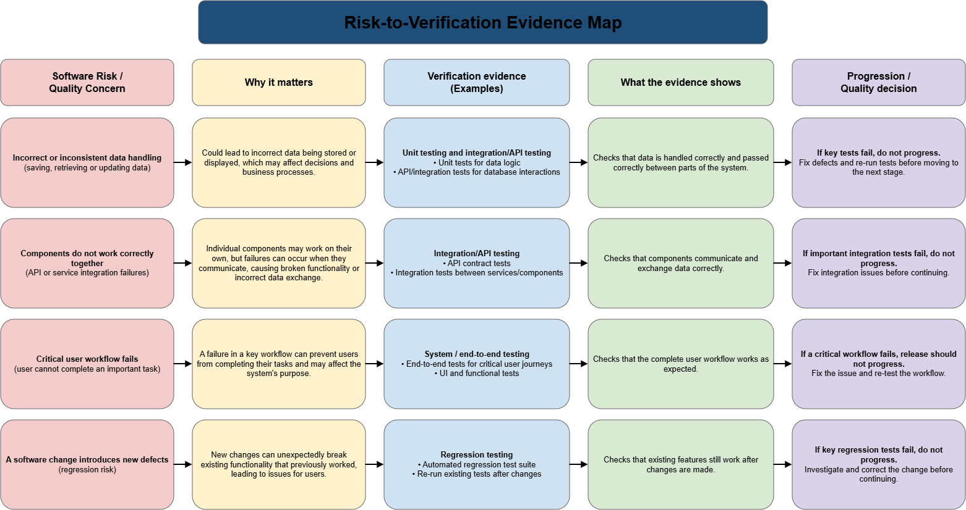

Question 2:
2.1 Threat Modelling
Threat Modelling is the act of heavily interrogating the chosen architecture to identify possible security threats as well as their causes and types of attacks that can happen, while prioritising these threats and preparing mitigation strategies against them. The overall outcome is to mitigate these threats, limit external vulnerabilities and reduce attack surface (Winnie Mbaka, 2022).
This technique requires a significant amount of manual effort. There is also usually a need for security and domain expertise. One approach of Threat Modelling is a security-by-design technique called STRIDE that was developed by Microsoft. A technique that aims to identify any security issues before the system is even implemented (Winnie Mbaka, 2022).

STRIDE six threat categories:
- S- Spoofing
Pretending to be another user or system.
- T- Tampering
Altering data or code without authorisation.
- R- Repudiation
Denying an action with no way to prove otherwise.
- I- Information Disclosure
Exposing data to people not entitled to it.
- D- Denial of Service
Making the system unavailable.
- E- Elevation of Privilege
Gaining more access than granted.
STRIDE is model based. There is a Data Flow Diagram (DFD) of the architecture. The external entities, data stores and flows, and trust boundaries that separate elements by the granted privilege level.

Two types:
- Per element: analysing each DFD element on its own. Each element has a table describing its most prominent threats.
- Per interaction: analysing each interaction as origin, destination and the data flow. Requires a larger mapping table and is more suited to experts (Winnie Mbaka, 2022).

STRIDE does have its limits it should be used as a structured prompt for thinking and does not guarantee completeness. (Anton Konev, 2022).
Per Element is more suited to smaller teams with little expertise and can help as a prompt to identify threats in the system. Threat modelling supports decision making as the threats identified can cause a need for possible change of architecture or data flow processes of the system. So, it can influence the decision the architecture/persistence decision or the change of these already made decisions.

2.2 Four Security Concerns

Chosen Concerns:
- Authentication, (Andrew van der Stock, 2021).
- Authorisation/Access control, (OWASP, 2025) (Andrew van der Stock, 2021).
- Secrets/Configuration, (OWASP, n.d.).
- Dependency vulnerabilities, (OWASP, n.d.).

2.3 Threat-to-Control Traceability Table
Threat / misuse | Security requirement or control objective | Possible engineering control | Verification evidence | Residual risk / limitation
Credential stuffing or brute-force attempts against login. Session reuse after logout (Andrew van der Stock, 2021). | Only the legitimate user can authenticate and hold a session. | Limit or delay failed logins. Store hashed passwords. A server-side session manager issues a new random ID after login, with idle and absolute timeouts. Log failures and alert on attacks (Andrew van der Stock, 2021). | Tests that repeated failures trigger limiting, that sessions expire and are invalidated on logout, and that stored passwords are not in plain text. | Limiting failed logins can itself be abused to lock real users out. Stolen valid credentials can still work.
A user reads or changes another user's record, or accesses a function outside their role (OWASP, 2025). | Every action is checked against what that caller may do to that resource. | Authorization enforced in trusted server-side code on every request, deny by default (Andrew van der Stock, 2021). | Tests that request another user's record or a restricted function and expect refusal. | One later-added endpoint without the check reopens the gap.
Database password or API key hardcoded in source or scattered through configuration. | Secrets are never stored in code and are centrally controlled. | Centralized storage, provisioning, rotation, and auditing are in place, with least-privilege access to secrets and automated rotation (OWASP, n.d.). | Audit records show who accessed or updated a secret and when; automated scans look for secret patterns in commits (OWASP, n.d.). | A leaked secret remains exposed until rotated, and if the secrets service becomes unavailable, recovery can be blocked.
Third-party library with a known vulnerability. | Dependencies are identified, tracked, and free of known issues. | Automated dependency analysis runs from the start of the project, with fixes applied when problems are found (OWASP, n.d.). | The scan report shows no unresolved serious findings at release. | Only known/disclosed vulnerabilities are detected, so unknown flaws can remain.

2.4 Secure design, Secure coding and Dependency/Security Checks

- Secure Design is preventing security issues at the architectural design level.
According to OWASP secure design is a methodology that continuously evaluates threats by recommending integrating threat modelling into development. Particularly to data flows, access control, or other security control changes (OWASP, 2025). This shows that secure design is more than just a security tool. It helps to establish security requirements that must be followed in implementation, the secure coding.
- Secure Coding takes the security architectural requirements/decisions and safely implements them in actual source code.
OWASP identifies the top 10 risks such as Broken Access Control, Injection, Authentication Failures and Insecure Design (OWASP, 2025). Making good security design insufficient as a developer can still implement incorrectly thus the need for secure coding.
- Dependency/Security Checks identify risks outside of the source code.
Even if the source code is secure a third-party dependency can create a security weakness in the application.

Therefore, they all interact with and complement each other and need to be considered together.

  - AI/Automated Security Limitations

Limitation 1:
Automated security tools don’t catch every vulnerability
Relying solely on automated scanners has a major drawback: a scanner can only spot weaknesses its analysis methods and rules can recognize. (Kaixuan Li, 2023) tested seven free or open-source SAST tools for Java. While the tools did well on synthetic benchmarks, they found only 12.7% of vulnerabilities in the real-world benchmark. Even combining all tools’ detections left 70.9% of vulnerabilities unseen. The authors highlighted weaknesses in resource control and insufficiently neutralized input/output as areas where detection is hard (Kaixuan Li, 2023).
This matters because it shows that a scanner’s findings reflect only the vulnerabilities it detects, not all that exist. The results depend on the scanner, its rules, and the type of vulnerability studied. Also, Li et al.’s study focused on Java and free or open-source SAST tools, so the findings shouldn’t automatically be applied to every commercial scanner or programming language (Kaixuan Li, 2023).
So, automated scanning helps identify known or recognizable patterns, but it doesn’t prove that the application’s security requirements are fully met.

No high security vulnerabilities detected by a scanner does not mean there are the application doesn’t have any high security vulnerabilities. It means that the scanner according to the rules it follows and what it can analyse could not identify any vulnerabilities. So, they may be vulnerabilities that exist and have not been identified.
(Kaixuan Li, 2023) provide direct evidence for this issue. Their Static Application Security Testing (SAST) evaluation showed that even when several tools are used together, a sizable number of real-world vulnerabilities can be missed.

Limitation 2:
AI-generated code and recommendations can introduce vulnerabilities.
AI coding assistants bring a different risk the suggestion itself may be insecure.
(Hammond Pearce, 2021) studied GitHub Copilot with 89 scenarios drawn from security weaknesses in MITRE’s CWE Top 25. They produced 1,689 programs, and about 40% were found to be vulnerable.
This does not mean that 40% of all modern AI-generated code is insecure. The experiment created security-focused scenarios and evaluated a 2021 version of Copilot. So, the result should be read as evidence that AI-generated code cannot be trusted to be secure by default, not as a current vulnerability rate for every AI coding assistant.
The limitation matters especially when developers accept AI-generated security guidance without checking it themselves. AI can output code that seems technically sound but still hides a security weakness.

There’s another problem when AI helps produce the code. (Neil Perry, 2023) found that participants using an AI assistant were more likely to think their code is secure, even though it ended up less secure in the study. So, a clean scanner result shouldn’t make developers stop scrutinizing AI-generated code.

What tools can detect:
- Known vulnerability patterns
- Certain insecure coding practices
- Some injection-related weaknesses
- Known dependency vulnerabilities
- Configuration problems recognized by their rules
- Specific weaknesses that match their detection rules
- Security issues within the tool’s analysis scope

What remains unproven:
- That no vulnerabilities exist
- That the entire application is secure
- That all inputs are safely handled
- That dependencies contain no unknown vulnerabilities
- That the configuration satisfies the application's intended security policy
- That business logic and access-control requirements are correct - That vulnerabilities outside that scope do not exist

Question 4:
Research finding | Engineering concern it addresses | Candidate approach / evidence to consider | Trade-off / limitation found in research | Decision M3 must still make
Verification effort should be based on risk rather than testing every part of the system equally. | High-risk or critical functionality may fail without enough verification. | Risk-based verification using likelihood, impact and business/technical criticality to determine verification depth. | Risk assessment depends on correctly identifying and assessing risks, and lower-risk areas still require some verification. | Which CivicConnect risks and features require deeper verification, and how much evidence should be required for each?
Different testing levels provide different forms of quality evidence and should be used together where appropriate. | Defects may occur within individual components, between integrated components or across complete user workflows. | Unit, integration/API and system/end-to-end testing can provide complementary verification evidence. | No individual testing level proves complete software quality, and broader testing may require more time, data and representative environments. | Which combination of verification evidence should CivicConnect require for different risks and progression decisions?
Security needs to be addressed at every level of development | Security Engineering & Threat Based Controls. | Possible use of STRIDE in identifying threats across the chosen architecture and system design. | Identification of threats may lead to changes in approach and possibly architecture. Choosing the per element STRIDE will be easier for team to handle but may miss certain vulnerabilities. | Which STRIDE approach should M3 use and will it sufficient to identify the system's security threats.
Automated security tools do not detect every vulnerability only what they are trained to detect. | Security verification & vulnerability detection | Use automated tools like SAST and security scanning in development process but do not rely on them. Pair with manual security review and testing | The automated tools may not pick up on all vulnerabilities with their defined analysis methods and rules. Difficult and unknown vulnerabilities may remain. Research may not apply to all language scanners as referenced study focused on Java and free open-source SAST tools. | How much should M3 rely on automated security scanning versus manual security review and testing.

AI Research & Verification Record

Team member | AI tool / use | Purpose | Output used? | How independently verified | What was changed/rejected
Liam Axel Ince | Claude | Research assistance in finding sources | Selected relevant and agreeable sources. | Checked whether the source and the information it contained was relevant to the topic I was discussing and whether the source was viable and accessible. | Rejected 3 sources as I feel they were unreliable and some were just about general principles I was not discussing so they were not viable. Kept the sources that I thought made the best research material for me.
Ofentse Vilakazi | ChatGPT | Research assistance in finding sources | Selected the relevant sources | Checked that the sources were correct and relevant to the information needed | I rejected 2 sources because they weren’t within the 5 year’s time span and some were irrelevant to the information

References
Agh, H., Azamnouri, A. & Wagner, S., 2024. Software product line testing: a systematic literature review. Empirical Software Engineering, 29(6), pp. 1-61.
Alégroth, E., Chatzipetrou, P., Gorschek, T. & Yu, L., 2023. Automated NFR testing in continuous integration environments: a multi-case study of Nordic companies. Empirical Software Engineering, 28(6), pp. 1-29.
Ali, N. b. et al., 2025. Quality attributes of test cases and test suites – importance & challenges from practitioners’ perspectives. Software Quality Journal, Volume 33, pp. 1-38.
Ardila, C. A., Bastidas, M. I. & Pardo, C. J., 2021. A Systematic Literature Mapping: Risk-Based Testing in Software Development. Ingeniería y Competitividad, 23(1), pp. 1-18.
Bogner, J., Hellhake, D., Schmid, T. & Wagner, S., 2022. Towards using coupling measures to guide black-box integration testing in component-based systems. Software Testing, Verification & Reliability, 32(4), pp. 1-20.
Cederbladh, J., Cicchetti, A. & Suryadevara, J., 2024. Early Validation and Verification of System Behaviour in Model-based Systems Engineering: A Systematic Literature Review. ACM Transactions on Software Engineering and Methodology (TOSEM), 33(3), p. 1–67.
De Lucia, A. et al., 2024. Toward granular search-based automatic unit test case generation. Empirical Software Engineering, 29(4), pp. 1-49.
Depar, M. H. et al., 2021. A Methodology for Incorporating Quality Assurance Practices during Software Development Life Cycle. International Journal of Advanced Trends in Computer Science and Engineering (IJATCSE), 10(3), p. 2296–2301.
Ishikawa, H. & Kato, D., 2024. Quality Control Methods Using Quality Characteristics in Development and Operations. Digital, 4(1), p. 232–243.
Khatami, A. & Zaidman, A., 2024. State-of-the-practice in quality assurance in Java-based open source software development. Software: Practice and Experience, 54(8), pp. 1-39.
Lathouwers, S., Liu, Y. & Zaytsev, V., 2025. Extract, model, refine: improved modelling of program verification tools through data enrichment. Software and Systems Modeling, 24(4), p. 1293–1313.
Liu, Z., Mäntylä, M. V., Markkula, J. & Wang, Y., 2022. Test automation maturity improves product quality—Quantitative study of open source projects using continuous integration. Journal of Systems and Software, Volume 188, pp. 1-38.
Naprawski, T., 2023. Best Practices for Knowledge and Quality Management in IT Projects. Szczecin, Poland, Elsevier B.V..
Reid, S., 2024. Risk-Based Testing for AI. [Online]
Available at: https://softwaretestingstandard.org/2024/11/03/risk-based-testing-for-ai/
[Accessed 25 September 2026].

Andrew van der Stock, B. G. N. S. T. G., 2021. A01:2021 – Broken Access Control. [Online]
Available at: https://top10.owasp.org/2021/A01_2021-Broken_Access_Control/
[Accessed 26 09 2026].
Andrew van der Stock, B. G. N. S. T. G., 2021. A07:2021 – Identification and Authentication Failures. [Online]
Available at: https://top10.owasp.org/2021/A07_2021-Identification_and_Authentication_Failures/
[Accessed 26 09 2026].
Anton Konev, A. S. M. K. V. A. A. N., 2022. A Survey on Threat-Modeling Techniques: Protected Objects and Classification of Threats. [Online]
Available at: https://www.mdpi.com/2073-8994/14/3/549
[Accessed 26 09 2026].
Hammond Pearce, B. A. B. T. B. D.-G. R. K., 2021. arXiv. [Online]
Available at: https://arxiv.org/abs/2108.09293
[Accessed 27 09 2026].
Kaixuan Li, S. C. L. F. R. F. H. L. C. L. Y. L. Y. C., 2023. Comparison and Evaluation on Static Application Security Testing (SAST) Tools for Java. [Online]
Available at: https://dl.acm.org/doi/10.1145/3611643.3616262
[Accessed 27 09 2026].
Neil Perry, M. S. D. K. D. B., 2023. Do Users Write More Insecure Code with AI Assistants?. [Online]
Available at: https://dl.acm.org/doi/10.1145/3576915.3623157
[Accessed 27 09 2026].
OWASP, 2025. Authentication Cheat Sheet. [Online]
Available at: https://cheatsheetseries.owasp.org/cheatsheets/Authentication_Cheat_Sheet.html
[Accessed 26 09 2026].
OWASP, 2025. OWASP Top 10:2025, A06:2025 Insecure Design. [Online]
Available at: https://top10.owasp.org/2025/A06_2025-Insecure_Design/
[Accessed 27 09 2026].
OWASP, n.d.. Secrets Management Cheat Sheet. [Online]
Available at: https://cheatsheetseries.owasp.org/cheatsheets/Secrets_Management_Cheat_Sheet.html
[Accessed 26 09 2026].
OWASP, n.d.. Vulnerable Dependency Management Cheat Sheet. [Online]
Available at: https://cheatsheetseries.owasp.org/cheatsheets/Vulnerable_Dependency_Management_Cheat_Sheet.html
[Accessed 26 09 2026].
Winnie Mbaka, K. T., 2022. A replication of a controlled experiment with two STRIDE. [Online]
Available at: https://arxiv.org/abs/2208.01524
[Accessed 26 09 2026].

